CST 352 – Assignment 2
Wilsonville, Spring 2020

Create a simple memory manager using ONE of the following:
- C++ on UNIX
- C++ on Windows

Define virtual base class MemoryPool that manages a chunk of memory:
- Takes size of pool in constructor (# of bytes)
- Allocate the pool of memory in the constructor
- Method virtual void * Allocate(unsigned int nbytes) returns a pointer to a free memory block or throws an OutOfMemory exception
- Method virtual void Free(void * block) deallocates the memory block, returning it to the pool
- Method virtual void DebugPrint() prints current state of memory pool, showing which blocks exist, their size and whether they are free or allocated

Define derived class FirstFitPool that uses the first-fit algorithm to manage the pool

Define derived class BestFitPool that uses the best-fit algorithm the pool

Define class StringQueue that uses a MemoryPool for storing it’s strings:
- Take a MemoryPool pointer in constructor
- Method void Insert(char * s) copies the string into space allocated in the pool and adds it to the tail of the queue or throws a FullException if there is no space available in the pool
- method char * Peek() returns a pointer to the string in the pool at the head of the queue or NULL if empty
- Method void Remove() removes the string at the head of the queue

Implement a main() that tests the operation of the queue and the memory pool. Make sure to test normal operations with sufficient memory and cases where memory is exhausted. Your tests should demonstrate behaviors of both FirstFitPool and BestFitPool. Use DebugPrint() to print out the state of the pool to show how it operates.

Extra Credit: Implement a third class, called BuddyPool, derived from MemoryPool, that implements the Buddy System strategy. Demonstrate how this improves memory management in your main().

Turn in your source code on Canvas in a zip file called CST352_Assign2_your_name.zip (e.g. “CST352_Assign2_Pete_Myers.zip”. The instructor should be able to compile, run and verify your program. This means you need to include your Solution/Project or Makefile as appropriate.

Design
Memory Pool and implementations…

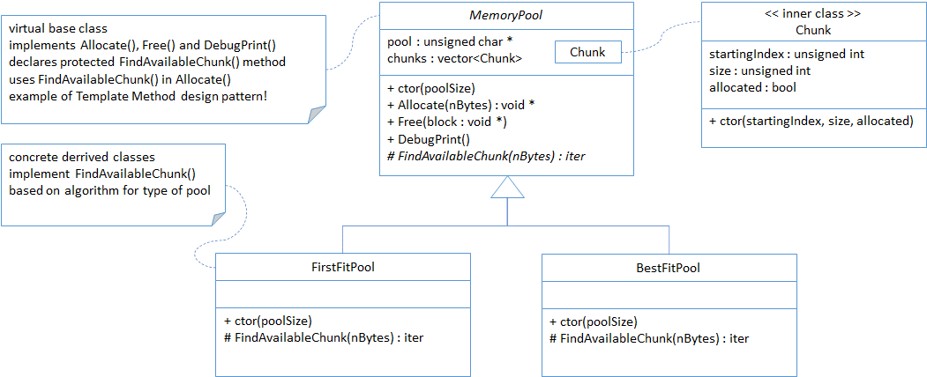

String Queue and use of Memory Pool…

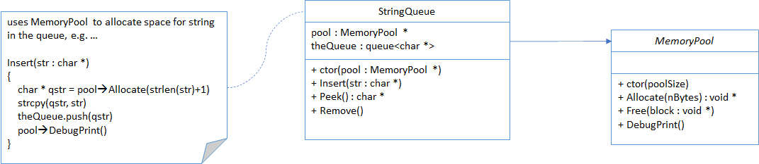

Example main()…

